Service contents

* Producer
  + Can distribute whole food to be treated as food splinter
  + We provide country-level store support based on the amount of food distributed at each store
  + Raising awareness by food sharing service.
  + Become an eco-friendly shop
* Consumer
  + Fresh free food can be obtained
  + Can have many experiences on food
  + Use of website services can have a positive impact directly on environmental protection

Motivation to make this

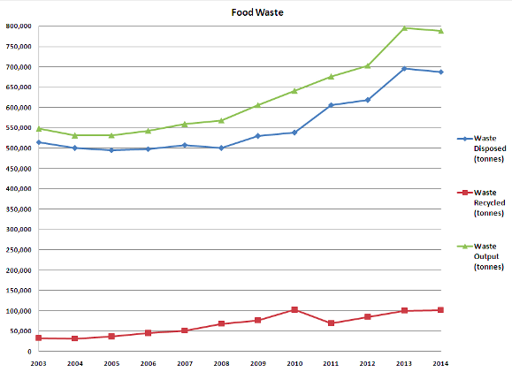

<Increment graph of food Waste>

Every year, the importance of environmental issues is rapidly increasing. We thought about how to handle food wastes that occupy a large part of them.  
One third of the food is now being abandoned and the cost of food disposal reach $800 million. So we will make good use of this situation and create a situation where both consumers and producers will benefit.  
Specifically, We will create a system where the restaurant owner uploads leftover food that can not be sold along with the expiration date to a web page, and that the necessary consumer buys at a discounted price or gets it for free.

Restaurants that use these systems heavily will get credits, and there will be adequate compensation for them. This allows the store to gain credit, reduce the cost of disposing of food waste, and consumers can also get the food they want at a reasonable price.

Introduce Website

* Menu divided by Priority
  + Latest - Posts start from the latest posts.
  + Near around - It will display from the nearest store.
  + Reputation – Consumer can rate quality of food from store
  + Discount Information – store can sell food, but it should be discounted
* The list of Post
  + Picture
  + Store name
  + Information of food
  + Update time
  + Expiration date
  + Provider memo